

**CSE-316**

**IN**

**ELCTRONIC AND COMMUNICATION ENGINEERING**

**OS ASSIGNMENT**

***Submitted by submitted to***

**NAME:**MOHAN SAI **MAM:**MANJITKAUR,mam

**ROLL:** A01

**SEC:**E1711

**Grouo:**1

**Email:**boyamohansai@gmail.com

**GITHUB LINK:**

**QUESTION NO 16:**

A barrier is a tool for synchronizing the activity of a number of threads. When a thread reaches

a barrier point, it cannot proceed until all other threads have reached this point as well. When the

last thread reaches the barrier point, all threads are released and can resume concurrent execution.

Assume that the barrier is initialized to N —the number of threads that must wait at the barrier

point:

init(N);

Each thread then performs some work until it reaches the barrier point:

/* do some work for awhile */

barrier point();

/* do some work for awhile */

Using synchronization tools described in this chapter, construct a barrier

that implements the following API :

• int init(int n) —Initializes the barrier to the specified size.

• int barrier point(void) —Identifies the barrier point. All

threads are released from the barrier when the last thread reaches this point.

**Barriers**

a barrier is a type of synchronization method. A barrier for a group of threads or processes in the

source code means any thread/process must stop at this point and cannot proceed until all other

threads/processes reach this barrier.

A barrier is a method to implement synchronization. Synchronization ensures that concurrently

executing threads or processes do not execute specific portions of the program at the same time.

When a barrier is inserted at a specific point in a program for a group of threads [processes], any

thread [process] must stop at this point and cannot proceed until all other threads [processes] reach

this barrier.



**Algorithm:**

1. initialize barrier_size and thread_count;

2. create threads

3. threads doing some work

4. threads waiting at the barrier.

5. barrier is released when last thread comes at the thread.

6. all threads complete thier task and exit.

7. exit.

**Complexity:**

O (n) complexity. “n” is no of thread_count.

**Outputs:**

**Case 1:when barrier and thread are equal**

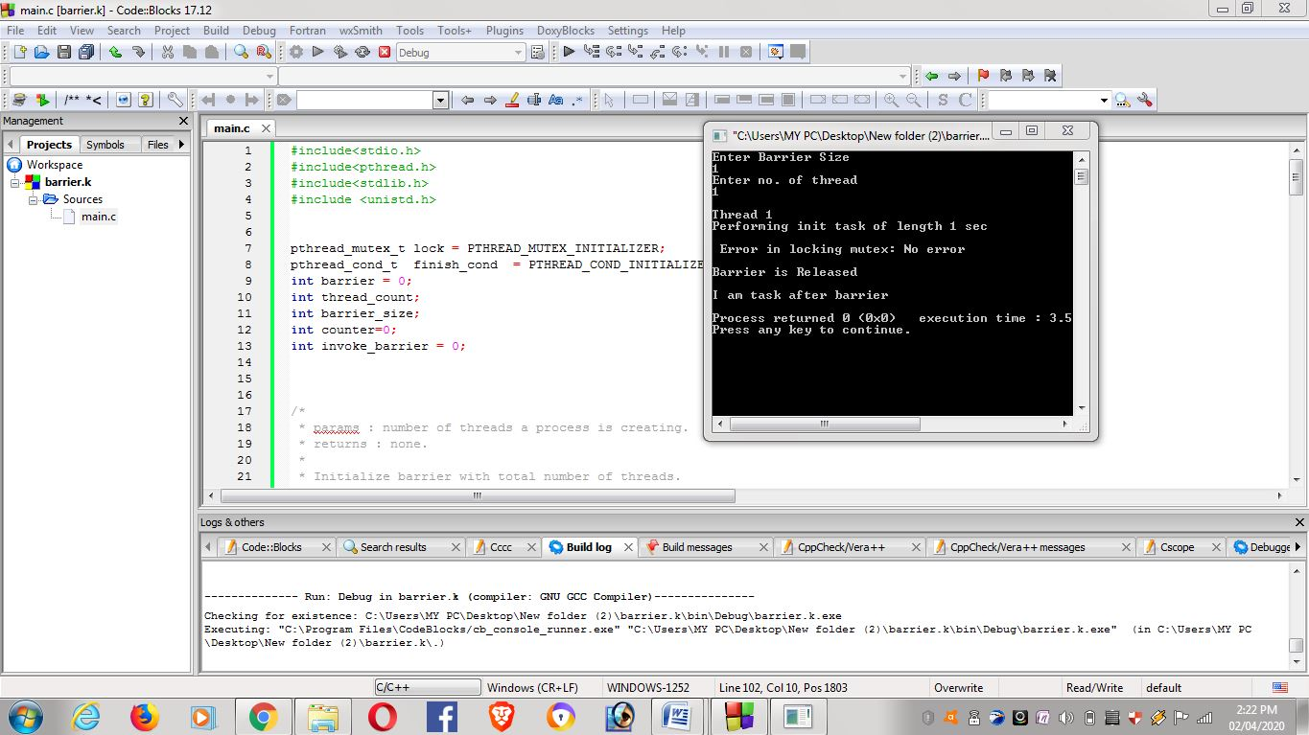

**Case-2:when barrier less than thread**

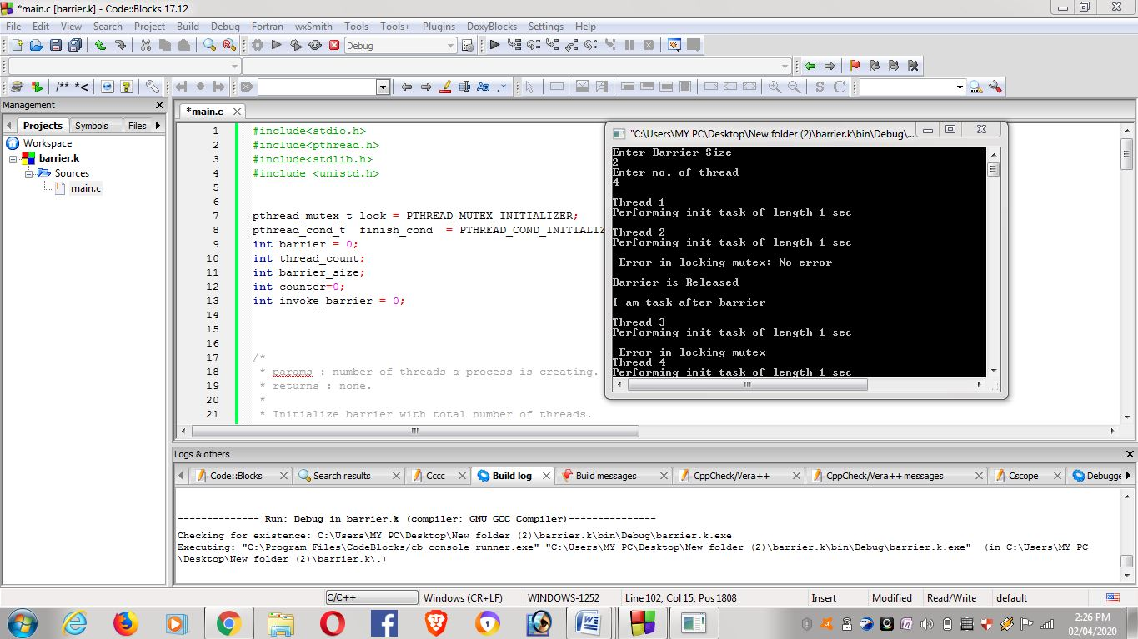

**Case-3** **:when barrier more than thread**

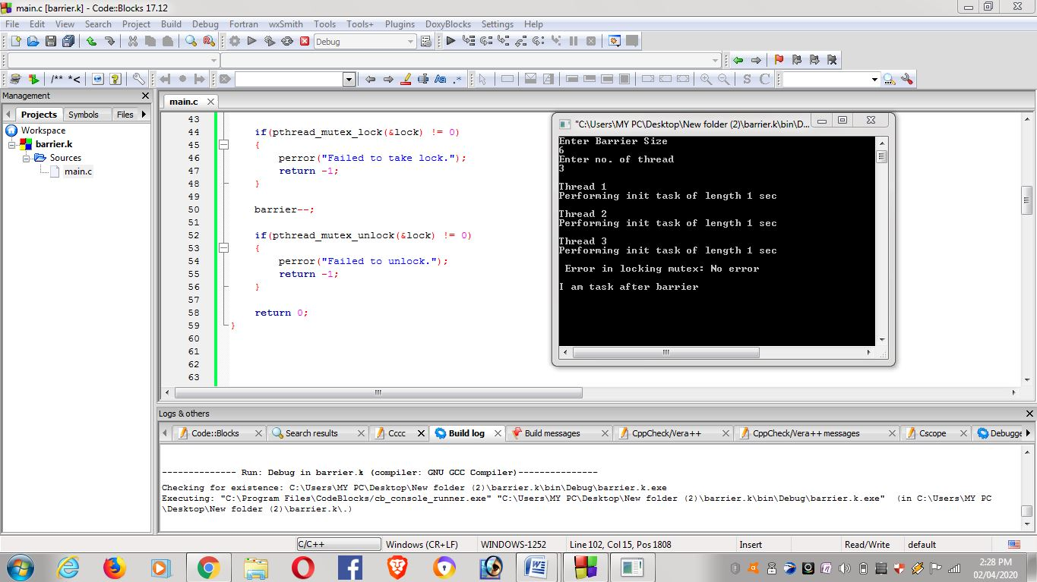

**Case-4:when the barrier is zero**

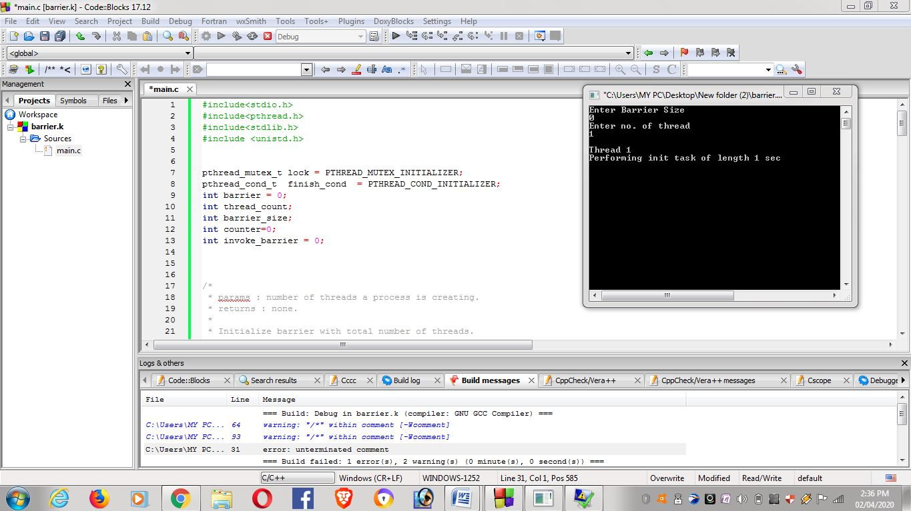

**Case-5:when thread is given as zero**

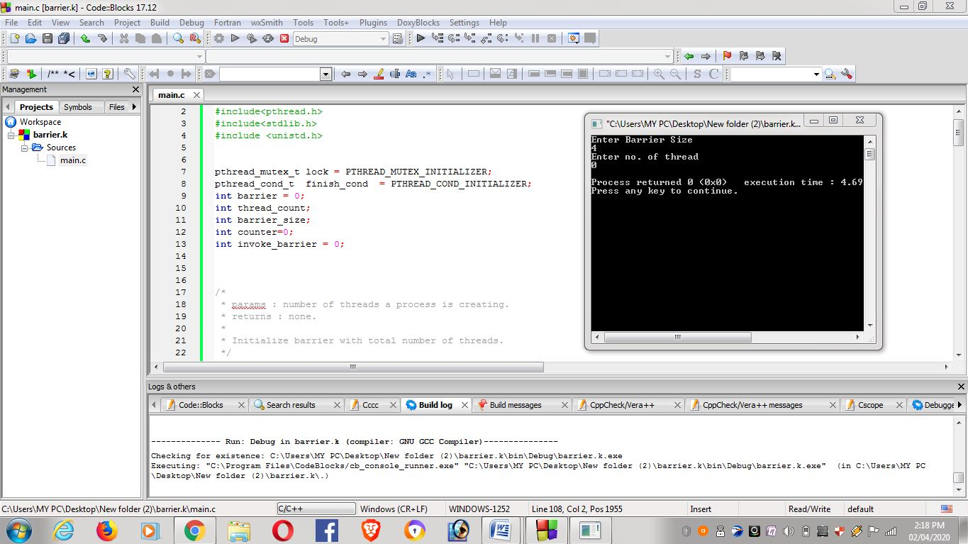

**Case-6:** **when user enter invalid inputs like –string ,negative etc..**

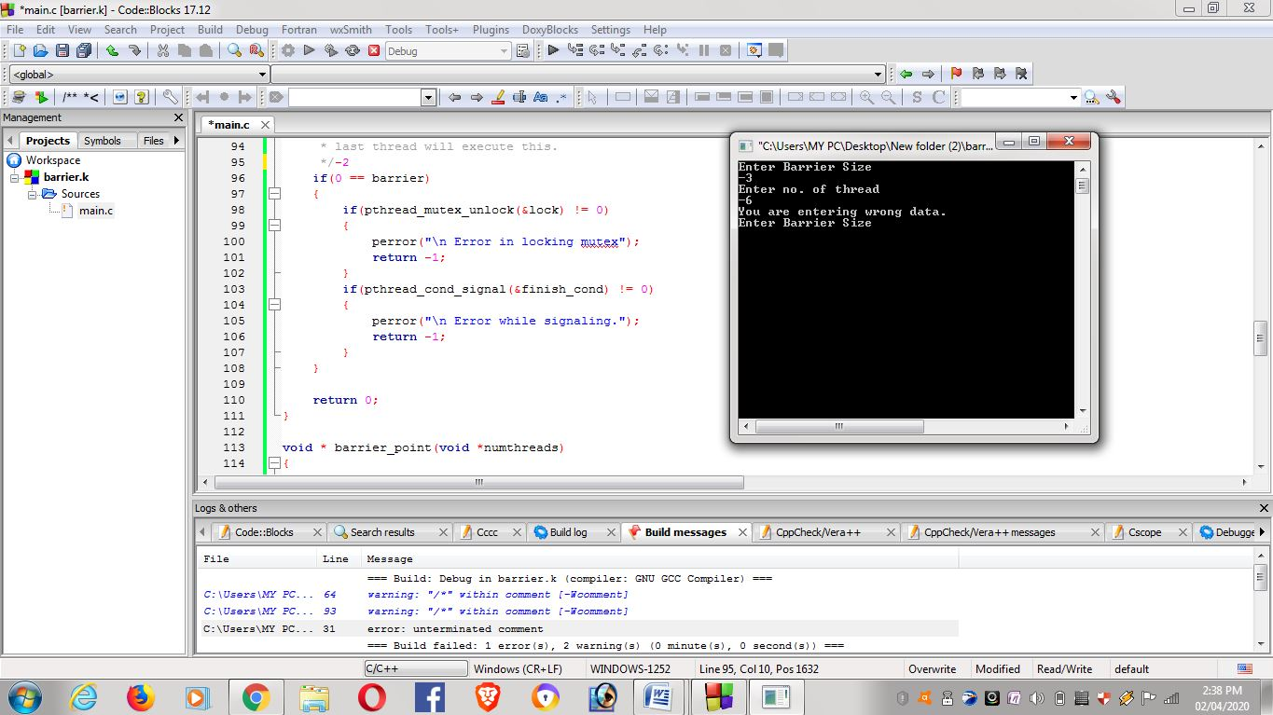

**Github link:** <https://github.com/Mohansai-boya/Mohan>

.